

Product Dissection for Alphabet’s Smart Healthcare System

Company Overview:

Alphabet Inc. is an American multinational conglomerate, a new public holding company headquartered in Mountain view, California. Announced in August 2015, Created on October 2nd, 2015 through a restructuring of Google and became the parent company of google in several former google subsidiaries. Lary Page and Sergey Brin, the two co-founders of Google remained as controlling shareholders, board members and employees at Alphabet. Currently, Alphabet is the world’s third largest technology company by revenue (after Amazon and Apple) and In 2025, it was ranked 8th in the Fortune 500 list of the largest US companies by revenue. Their reported revenue for that year is $307.394 billion.
Established to encourage a desire to make the core google business cleaner and more accountable, while allowing greater autonomy to group companies that automate in businesses other than internet services. Subsidiaries were moved from google to alphabet to narrow google’s scope.
In December 2019, founders Page and Brin resigned from their executive posts, handed the CEO role to Sundar Pichai, CEO of Google, while they remained employees, board members and controlling shareholders of Alphabet Inc.
Name Alphabet was suggested as it meant a collection of 26 letters in the English language which represented the 26 subsidiaries that Google Inc. had under its umbrella which reversed into Alpha-bet where ‘Alpha’ is the investment return above benchmark which is the fundamental goal.

Product Dissection and Real-World Problems Solved by Alphabet Healthcare:

Alphabet, through its dedicated initiative Google Health, is pursuing a powerful and deeply human mission: to harness Google’s expansive technology to help people everywhere live longer, healthier lives. With years of effort already invested in integrating Google’s capabilities into the healthcare ecosystem, the company is now embracing a new era powered by artificial intelligence. This moment represents one of the most exciting inflection points in the history of medicine—where AI is not only augmenting traditional care but actively reshaping how healthcare is accessed, delivered, and experienced.

At the heart of Google Health’s approach is the goal of meeting people wherever they are in their health journeys. This includes delivering accurate, relevant, and culturally tailored health information through platforms like Google Search and YouTube. Collaborations with global health institutions such as the UK’s National Health Service, the Mayo Clinic in the United States, and Apollo Hospitals in India ensure that the information shared is both trustworthy and regionally applicable. Through Google’s hardware ecosystem—including Fitbit and Pixel—users receive personalized health insights related to sleep, heart rate, and body temperature, allowing them to better understand and monitor their physical well-being in real time.

Artificial intelligence plays a central role in Google’s health ambitions. With the introduction of generative AI models like MedLM, Google is enabling hospitals and researchers to solve long-standing challenges in medical data processing, such as summarizing complex patient records and improving communication between clinicians. These tools enhance productivity while preserving the human element of care. Meanwhile, breakthroughs like AlphaFold—Google DeepMind’s revolutionary AI system for predicting protein structures—are helping scientists decode biological mechanisms that may one day transform disease treatment. This advancement in AI is not merely theoretical; it is already catalyzing progress in clinical research and drug development.

Beyond individuals, Google is focused on empowering health organizations. Through Google Cloud, the company provides scalable infrastructure and AI-driven tools to hospitals, labs, and digital health companies. These platforms allow healthcare providers to store, manage, and analyze data securely, streamline workflows, reduce administrative overhead, and make faster, data-informed decisions. In a sector often burdened by inefficiency and siloed systems, this technological backbone supports a more integrated, responsive, and cost-effective model of care.

Importantly, Google recognizes that solving complex healthcare problems cannot be done alone. It is building a thriving health ecosystem through strategic collaborations with startups, governments, NGOs, and global public health organizations. Google Cloud has become the foundation for many health technology innovators, with over 90% of health-focused generative AI startups—often valued at over a billion dollars—choosing it as their core infrastructure. These partnerships foster innovation at scale and ensure that solutions are not only cutting-edge but also deeply rooted in real-world needs.

As Google Health continues to grow, it remains grounded in the ethical principle taught in medical training: “First, do no harm.” All of its AI development is guided by clearly articulated principles focused on safety, fairness, inclusivity, and trust. The company is committed to designing its health products with equity and accessibility in mind, ensuring that no one is left behind due to geography, language, or social barriers. This deep sense of responsibility reflects Google’s long-term vision—to use technology as a force for global good.

In conclusion, Google Health represents one of Alphabet’s most ambitious and impactful ventures. By combining AI, cloud infrastructure, and consumer technology, it is creating a comprehensive and intelligent health ecosystem that benefits individuals, caregivers, researchers, and institutions alike. As we look toward the future of medicine, Google Health stands as a powerful example of how responsible innovation can lead to a healthier, more connected world for all.

Case Study: Real-World Problems and Alphabet Health's Innovative Solutions

Artificial Intelligence has emerged as a transformative force in healthcare, and Alphabet, through Google Health and Google Cloud, is actively redefining how medicine is practiced, documented, and delivered. Their MedLM family of models, built on the foundation of Med-PaLM 2, exemplifies the application of generative AI in solving some of the most persistent and costly problems in the healthcare sector. From improving clinical efficiency to accelerating drug discovery, Alphabet’s innovations are being tested and adopted by major players in the healthcare ecosystem. The following real-world problems demonstrate how Alphabet’s technology is enabling meaningful solutions.

Problem 1: Time-Consuming and Inefficient Medical Documentation

Real-World Challenge: As our lives become increasingly digital, the lack of genuine connections in online interactions has become a prevalent concern. Users often struggle to convey emotions and experiences effectively through text-based communication alone, leading to a disconnect in digital relationships.

Alphabet Health's Solution:
One of the most widespread issues faced by healthcare providers is the overwhelming burden of documentation. Physicians often spend hours transcribing notes or entering data into electronic health records (EHRs), which reduces time available for patient care and contributes to burnout. To address this, Alphabet has collaborated with HCA Healthcare and Augmedix to deploy an AI-powered ambient documentation solution using MedLM on Google Cloud’s Vertex AI platform. In pilot programs at four emergency department sites, physicians used hands-free devices equipped with the Augmedix app to convert spoken clinical conversations into structured medical notes. These notes are drafted instantly and reviewed in real-time, then automatically uploaded to the EHR system. The result is a significant improvement in note quality, faster documentation, and increased clinician efficiency. By minimizing administrative load, this solution also enhances the overall quality of patient interactions.

Problem 2: High Costs and Long Timelines in Drug Discovery
Real-World Challenge: The vast amount of content available online can overwhelm users, making it challenging to discover relevant and engaging content aligned with their interests.

Alphabet Health's Solution:
Drug discovery is notoriously slow, complex, and expensive, often taking years of research before a viable treatment is identified. BenchSci, a leader in AI-powered scientific research, is addressing this challenge by integrating MedLM into its ASCEND platform. ASCEND uses machine learning to decode and structure insights from over 100 million experiments, building a high-fidelity knowledge graph that maps relationships between biomarkers, diseases, and molecular pathways. With MedLM’s integration, the platform further enhances the precision and reliability of preclinical research. This empowers scientists to identify novel biomarkers more effectively and accelerates the path to therapeutic discovery, significantly reducing the cost and time associated with traditional research processes..

Problem 3: Inefficiencies in Healthcare Operations and Claims Processing
Real-World Challenge: Many individuals aspire to pursue creative endeavours, but finding a platform to showcase and monetize their talents can be daunting.

Alphabet Health's Solution:
Healthcare operations are often bogged down by manual, repetitive processes like claims review, enrollment validation, and interpretation of clinical documents—tasks that are both time-consuming and prone to human error. Alphabet’s partnership with Accenture seeks to overcome this through the integration of MedLM with Accenture’s Solutions.AI for Processing. This system interprets both structured and unstructured data to automate these traditionally slow processes. Leveraging Google Cloud’s Claims Acceleration Suite alongside MedLM, clinicians and administrative teams can now generate real-time insights from vast troves of patient data. This not only speeds up decision-making but also frees up resources to focus more directly on patient care, ultimately improving both efficiency and outcomes.

Problem 4: Navigating Provider Networks and Enhancing Member Experience
Real-World Challenge: Establishing a unique online identity can be challenging, as traditional text-based platforms often limit personal branding.

Alphabet Health's Solution:
Patients often struggle to understand which providers are available within their insurance networks, especially when trying to align care options with specific medical needs. This can lead to delays in care or incorrect provider selection. To resolve this, Deloitte, in collaboration with Google Cloud, is leveraging MedLM to develop an AI-enhanced provider search tool. This system uses generative AI to analyze provider directories, benefits documents, and user history to suggest personalized provider recommendations. The tool is currently being piloted to assist contact center agents in guiding health plan members more accurately. By simplifying the process of finding in-network care based on conditions, medications, and appointment history, this innovation ensures faster and more precise access to appropriate healthcare services.

Conclusion: Transforming Healthcare Through MedLM and Responsible AI:
Alphabet’s work through Google Health and MedLM is already reshaping the healthcare landscape. From automating clinical documentation and accelerating scientific discovery to improving health plan navigation and streamlining administrative operations, the real-world impact of MedLM is evident. What sets this initiative apart is not only the technological innovation but the ethical and collaborative framework behind it. With MedLM models being responsibly deployed in live healthcare environments, Alphabet is taking a measured, safety-focused approach—working closely with practitioners and researchers to ensure that generative AI is applied where it brings the most value. As access to MedLM expands globally, the future of healthcare looks increasingly intelligent, efficient, and human-centered.

Top Features of Alphabet Health:

- User Health Profiles: Alphabet Health’s platforms integrate user health data from various sources, including wearable devices like Fitbit and Pixel Watch, electronic health records, and self-reported inputs. These profiles serve as a comprehensive and personalized health dashboard for individuals. They include demographic data, health history, vitals, and behavioral trends, enabling a centralized, real-time view of a person’s health journey. Privacy settings and consent management tools allow users to control who accesses their data.

- Medical Records and Summarization: Through its MedLM models, Alphabet supports automated medical documentation by generating real-time summaries of patient encounters, diagnoses, medications, and treatments. These summaries reduce the burden of manual note-taking for clinicians and improve documentation accuracy. Integrated with EHR systems, this feature ensures streamlined access to structured clinical data. It helps providers make better-informed decisions quickly while maintaining compliance with data standards.

- AI-Generated Health Insights: Alphabet’s AI tools offer predictive and assistive capabilities such as risk assessments, disease likelihood scores, and early alerts based on user data. These insights are generated from longitudinal patterns, wearable inputs, and historical medical records. Tools like AlphaFold also contribute by mapping protein structures for drug research, supporting both individual diagnosis and public health innovation. These AI-driven outcomes assist clinicians in proactive care and personalized treatment planning.

- Trusted Health Information Delivery: Google Health enhances user education by delivering verified, culturally relevant medical content through platforms like Search and YouTube. In collaboration with global health partners like Mayo Clinic and NHS, it ensures that users receive region-specific, scientifically accurate guidance. Content includes symptom overviews, condition explainers, and public health updates, bridging the information gap for millions. This feature is critical for self-care and informed decision-making.

- Care Navigation and Provider Matching: With the help of generative AI, Alphabet is improving how users find healthcare providers by matching them based on insurance coverage, medical history, and specific health conditions. Interactive chatbots help patients navigate provider networks and book appointments more efficiently. This feature also supports call center agents in identifying the most appropriate care for each patient. It reduces delays and improves access to personalized, in-network care options.

- Health Monitoring via Wearables: Devices like Fitbit and Pixel continuously track physiological data such as sleep quality, heart rate, activity levels, and skin temperature. This data is analyzed to generate trends, detect anomalies, and trigger real-time alerts for both users and clinicians. Longitudinal tracking enables early detection of health issues and supports wellness coaching. The integration of wearable data into clinical workflows improves preventive care and remote monitoring.

- Clinical Research and Drug Discovery Tools: Alphabet supports preclinical research and trials through platforms like Verily and BenchSci, which leverage AI to process millions of experimental results. By building advanced knowledge graphs of biomarkers, diseases, and treatment outcomes, these tools accelerate scientific discovery. The integration of MedLM enhances research precision and reduces the time and cost of drug development. These platforms also help recruit eligible patients for studies and manage compliance.

Schema Description:

The schema for Alphabet Health involves multiple entities that represent different aspects of the healthcare platform. These entities include Users, HealthProfiles, DeviceData, Visits, Doctors, Hospitals, MedicalRecords, AIInsights, Alerts, Appointments, and HealthContent. Each entity contains specific attributes that capture healthcare data and define relationships across the system, enabling intelligent and personalized patient care.

User Entity:
Users are at the core of the Alphabet Health ecosystem. This entity contains demographic and contact information for individuals interacting with the platform:

- UserID (Primary Key): A unique identifier for each user.
- Name: The full name of the user.
- DOB: Date of birth.
- Gender: Gender identity of the user.
- Email: The user’s email address.
- Region: The geographic location or area the user belongs to.

Health Entity:
Health profiles hold static medical information about users that is used for personalized care and diagnostics.

- ProfileID (Primary Key): A unique identifier for each profile.
- UserID (Foreign Key referencing User Entity): Links the profile to the user.
- BloodGroup: The user’s blood group.
- Allergies: Known allergies.
- ChronicConditions: Pre-existing or ongoing health conditions.
- CreatedDate: The date when the profle was created.

DeviceData Entity:
The entity stores data collected from wearable devices like Fitbit and Pixel Watch:

- DeviceDataID (Primary Key): A unique identifier for each data entry.
- UserID (Foreign Key referencing User): Links the data to a specific user.
- DeviceType: Type of device used(e.g., smartwatch).
- HeartRate: Heart rate at the time of recording.
- SleepDuration: Total sleep duration in hours.
- Steps: Steps taken by the user.
- Tempreture: Body or skin tempreture.
- RecordTime: Timestamp of the data capture.

Visit Entity:
Visit records represent patient interactions with healthcare providers:

- VisitID (Primary Key): A unique identifier for each visit.
- UserID (Foreign Key referencing User): The patient involved.
- DoctorID (Foreign Key referencing Doctor): The facility where the visit occurred.
- VisitDate: Data and Time of the visit.
- VisitType: In-person or virtual.
- Notes: Additional notes taken during the visit.

MedicalRecord Entity:
Medical Records store clinical outcomes and treatment information from the patient visits:

- RecordID (Primary Key): A unique identifier for the records.
- VisitID(Foreign Key referencing Visit): Links the record to specific visit.
- Diagnosis: Diagonised condition(s).
- LabResults: Relevant test results.
- Medications: Prescribed medications.
- FollowUpDate: Scheduled follow-up date if needed.

AIInsight Entity:
AIInsights stores predictive insights or recommendations generated by AI models like MedLM:

- InsightID (Primary Key): A unique identifier for the insights.
- UserID(Foreign Key referencing User): The user for whom the insight is generated.
- GeneratedByModel: Name or version of the AI model used.
- InsightType: Type of insight(e.g., risk prediction).
- ConfidenceScore: AI model’s confidence in the prediction.
- GeneratedDate: Date of generation.
- PredictedCondition: The health condition predicted by the model.

Alert Entity:
Alert notify users or providers about critical conditions based on wearable or AI data:

- AlertID(Primary Key): A unique identifier for the alert.
- UserID(Foreign Key referencing User): Recipient of the alert.
- TriggeredBy: Source that generated the alert.
- Message: Alert content.
- AlertType: Type of alert(e.g., emergency, reminder).
- Timestamp: When the alert was generated.
- Status: Whether the alert has been read or not.

Doctor Entity:
This entity contains information about registered healthcare providers.

- DoctorID(Primary Key): A unique identifier for each doctor.
- Name: Full name of the doctor.
- Specialization: Medical speciality (e.g., cardiology).
- Email: Contact email.
- HospitalID(Foreign Key referencing Hospital): The hospital where the doctor works.
- ExperienceYears: Total years of experience

Hospital Entity:
Hospital and clinics where users receive care.

- HospitalID(Primary Key): A unique identifier for each facility.
- Name: Hospital name.
- City: City of location
- AccreditionStatus: Certfication or recognition.
- Country: Country where the hospital is located.

Appointment Entity:
Appointments are scheduled interactions between users and doctors.

- AppointmentID(Primary Key): A unique identifier for the appointment.
- UserID(Foreign Key referencing User): Patient booking the appointment.
- DoctorID(Foreign Key referencing Doctor): Doctor assigned.
- ScheduledDates: Date and time of appointment.
- Status: Current status (confirmed, completed, cancelled).
- Mode: Virtual or in-person.

HealthContent Entity:
Educational content shared with users through Google Search, YouTube, or direct delivery.

- ContentID(Primary Key): A unique identifier for the content piece.
- Topic: The subject of the content (e.g., diabetes, vaccination).
- Language: Language of the content.
- Region: Target region or audience.
- PartnerOrg: Organization that validated or provided the content.
- Status: Published, draft, etc.
- URL: Link to the content.

Relationships are:

- Users have multiple HealthProfiles, DeviceData, Appointments, Visits, AIInsights, and Alerts.
- Each Visit links a User with a Doctor and Hospital and generates a MedicalRecord.
- MedicalRecords are created per Visit and include diagnoses and prescriptions.
- Doctors work at Hospitals and see multiple Users through Visits and Appointments.
- AIInsights and DeviceData can generate Alerts for Users.
- HealthContent is regionally targeted and shown to Users via personalized feeds.

ER Diagram:

Let's construct an ER diagram that portrays the relationships and attributes of Alphabet Health’s schema. This diagram visually illustrates the system’s architecture, showing how entities such as users, visits, AI insights, and medical records are interconnected. Through this model, we understand how Alphabet Health enables intelligent, real-time health experiences by integrating wearable data, AI models, provider interactions, and educational content in a single framework.
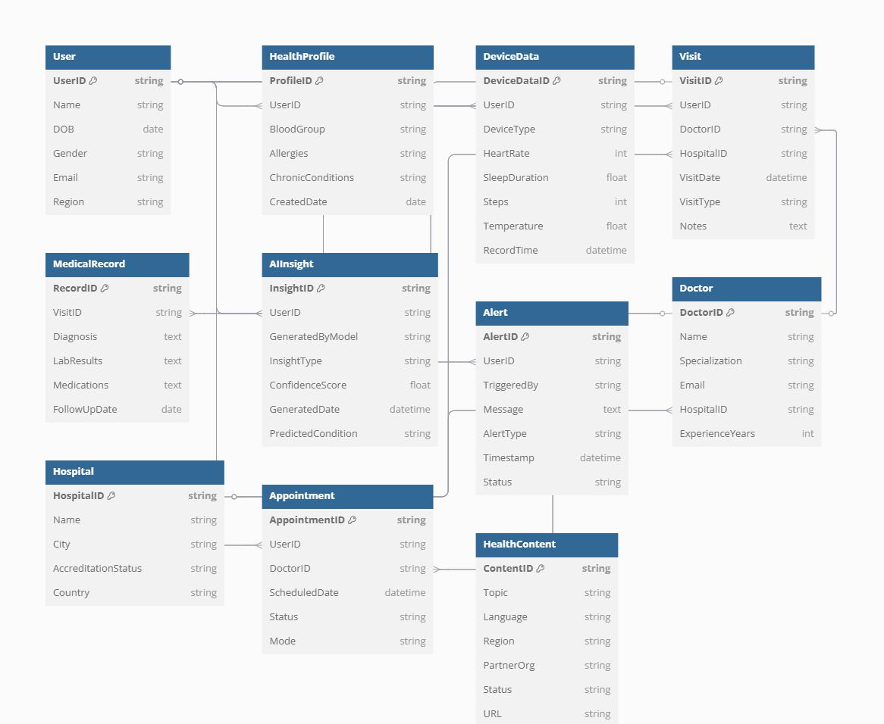

Conclusion

In this case study, we explored the schema and data relationships behind Alphabet Health’s intelligent healthcare platform. With AI-powered features like MedLM, wearable integrations, real-time alerts, and personalized recommendations, Alphabet Health represents the future of connected, proactive, and data-driven care. The platform’s schema reflects its mission to unify medical records, empower patients, support clinicians, and advance public health through technology. Understanding this schema allows us to appreciate how Alphabet leverages relational data models to transform global health experiences with precision, scale, and responsibility.

Created by Aditya tyagi

